West and Central Africa (WCA) workshop to prepare for the applications for the Global Fund 2020- 2022 grant cycle; 25-27 NOVEMBER 2019; HOTEL LAMANTIN, SALY SENEGAL.
MEETING HIGHLIGHTS

The WCA Joint United Nations Regional Team on HIV/AIDS (JURTA), in partnership with the Global Fund, Expertise France, and the WCA Civil Society Institute for Health and HIV convened a regional workshop to ensure that a pool of experts and country delegates who will be supporting country applications to the Global Fund 2020-22 grant cycle are fully equipped with the latest guidance materials on the application process, on the HIV,TB, and other cross cutting programme areas (incl latest UN guidance).

DAY 1 – presentations and reference materials are available here Day 1
Global Fund application process –
- What is new/different
  - Essential Data Tables- Pre-filled by Secretariat to encourage data-based analysis
  - Proritised above allocation request (PAAR) - To be developed and submitted at same time as funding request submission; Should be at least 30% of the allocation amount; and Should be focused on fewer, larger, high impact investments
  - Matching Funds - Question integrated in funding request
  - Payment for Results - Included as option in all forms to facilitate this approach
  - Titles and section names differ, but there are four thematic sections for each of the application approaches 1 Context; 2 Funding Request and Prioritization; 3 Implementation and 4 Sustainability
- National Strategic Plans (NSP) - The allocation-based funding model emphasizes alignment to country processes, and it aims to incentivize the development of robust, costed and prioritized NSP as well as the overall national health strategy
- Challenging Operating Environment (COE)
  - Half of the COE countries are in WCA (Mauritania, Burundi, CAR, Chad, Guinea, Guinea-Bissau, Liberia, Mali, Niger, Sierra Leone, DRC, Nigeria)
  - Flexibilities for COEs have been integrated throughout the requests. While certain flexibilities have been identified, others are available depending on country context. Categorization as a COE does not automatically guarantee eligibility for a flexibility.
  - COE countries are strongly encouraged to describe in the Summary of Country Context the challenges and fragilities that need to be taken into consideration during program(s) design and implementation.
  - Global Fund (GF) on-going efforts to :
    - Simplify processes : identify areas where implementation modalities and communication, audit/verification and reporting requirements can be simplified including re-evaluate additional safeguard measures and risk management measures (eg zero cash policy) and reprogramming with non-objection from the GF for a greater budgetary flexibility Eg in CAR: flexibility in use of reporting and verification systems in insecure and remote areas
    - Remove operational bottlenecks: identify operational flexibilities in grant implementation and reprogramming leading to better efficiency and results incl increased roles and responsibilities for regions and districts Eg in CAR and Chad: flexibility in contracting SRs or humanitarian actors to support implementation in difficult to reach areas
    - Build capacities: identify mechanisms and partnership frameworks to assist and reinforce capacities of MoH and national programs Eg. A guide for contingency planning has been developed to help country avoid services interruptions in emergencies.
    - Create innovative partnerships during emergencies: identify and map non-traditional partners who can support service delivery and supply chain. Eg partnerships with UNHCR, IOM, WFP and ICRC
- Risk management and mitigation
  - The Funding Request Forms include a specific risk sub-section. Applicants should be forward-looking and focus on a limited number of key anticipated implementation risks and mitigation measures. It is very important to prioritize the risks in the funding request. It is recommended to target a limited number of substantial risks in relation to the selected implementation entities and implementation modalities and to prioritize the risks in order of importance for the context of your country and component. Mitigation measures should also be SMART (specific, measurable, accessible, realistic, and time-bound). Finally, the responsible entities and the source of funding to cover the costs of the mitigation measures should also be indicated clearly. (Please refer to the instruction note).
  - Risk areas include Program Quality, Monitoring and Evaluation, Procurement, In-Country Supply Chain; Grant-Related Fraud & Fiduciary and Accounting and Financial Reporting; National Program Governance and Grant Oversight; Quality of Health Products; Risks related to human rights and gender; Macroeconomic factors; Instability of the country; Political risks and Other emerging risks
- Application Dos
  - Complete key annexes (e.g. Funding Landscape Table and Programmatic Gap Table) before starting to fill out the funding request narrative
  - Data should be consistent across funding request narratives and attachments (e.g. financial data across the funding request narrative, Funding Landscape Table and commitment letter). If the data / information is complete and analysis is comprehensive at the funding request submission stage, applicants should have a smoother grant-making process.
- Technical review panel (TRP)
  - The TRP is an independent group of experts that reviews each request for funding submitted to the Global Fund
  - Review criteria : Maximizing impact against HIV, TB, and malaria ; Building resilient and sustainable systems for health; Promotes and protects human rights and gender equality; Increasing effectiveness and efficiency: program implementation; and Sustainability and co-financing
- Recent TRP Report with observations on the 2017-2019 allocation cycle and recommendations
  - Recommendations 1: Improve Priority Setting; 2: Increase focus on prevention and reducing incidence; 3: Strengthen Cross-cutting Resilient and Sustainable Systems for Health (RSSH) programming; 4: Community Systems Strengthening; 5: Sustainability and Transition
  - HIV recommendations
    - Strategies to reach populations currently being left behind for HIV testing, treatment and prevention need to be increasingly focused on evidence-based interventions
    - Further improvements in data analytics to more appropriately target innovative interventions to fill gaps in cascades. Integration of facility-based and community-based data is required.
    - Increased attention to routine viral load measurement and treatment optimization. Higher attention to the roll out of Dolutegravir.
    - Innovative HIV prevention approaches to be scaled up, including biomedical prevention approaches. Pre-exposure prophylaxis (PrEP) programming was largely restricted to pilot programs due to challenges for many countries in translating the normative guidelines to specific contexts. Simplification of the guidelines may help countries to identify those who are most in need and initiate them on PrEP.
    - Programmatic silos for community-based prevention and facility-based treatment interventions remain a challenge. Opportunities are missed for providing valuable assistance with retention on treatment, for returning patients who are lost to follow up, and for maintaining viral suppression.
    - Increased attention will need to be paid to maintaining sustainable ART programs from domestic funding sources, which will benefit from increased rationalization of regimens.
    - Sustainability of many key and vulnerable population programs remains in doubt as countries are still reluctant to change policies and practices to allow domestic finances to fund activities requiring partnership with civil society.
- WCA Office of the Inspector General (OIG) Advisory report – summary of key advisory recommendations
- WCA initiative in response to WCA OIG advisory report -
  - 4 cohorts to roll out the initiative
    - Cohort 1 Guinea and Senegal by Sept 2019
    - Cohort 2 Cameroon, Gambia, Liberia, and Sierra Leone by Dec 2019
    - Cohort 3 Benin, Burkina Faso, Mali, Mauritania, Niger and Chad by March 2020
    - Cohort 4 Congo, CIV, Guinea Bissau, CAR and Togo by June 2020
  - 5 Steps
    - Step 1: Integrated Facts Base (internal review) (Project team and GF Country Team)
    - Step 2: Prioritization by the Secretariat (GF Country Team and Peer Team)
    - Step 3: Country mission (country and partner interaction)
    - Step 4: SMART Country Action Plans (Project team, GF Country Team and Managers) to be developed for all concerned countries by end 2020
    - Step 5: Validation of country action plans (Head of Grant Management Team)
  - But by end 2019 all concerned countries are to have finalised the first two steps, and the information gathered should help with planning for next cycle
- Regional grants - Humanity & Inclusion (HI) conducted 4 biobehavioural surveys to better understand the situation of men and women with disabilities in West Africa with regard to HIV/AIDS. Findings include that this is a group heavily affected by HIV/AIDS and it should be considered as a vulnerable population.

Core HIV information note and Modular Framework –
- Early engagement of in-country stakeholders and partners in assessment of progress and gaps is key.
- Five key investment principles for the 2020-2022 allocation period

- Allocative efficiency – Optimizing the distribution of resources to achieve maximum health impact (lives saved, infections averted). Allocative efficiency is realized by strategically apportioning program resources across interventions, population groups and sub-national geographies to maximize health impact. Funding requests should demonstrate how priorities have been determined, and resources allocated through all health funds available to the country including the portion requested from the Global Fund
- Implementation quality and efficiency - Delivering high quality interventions in line with normative guidance and securing minimum costs of a mix of inputs to produce a given health output or achieve a given health outcome.
- A funding request presenting strong technical efficiency might include the following features:
  - evidence to justify that the interventions proposed are technically most appropriate and in line with the latest normative technical guidance
  - optimal use of existing capacity, such as common laboratory services or combined training across diseases
  - mechanisms to address common bottlenecks in service delivery, such as stockouts or health worker constraints - ex. task-shifting
  - efforts to deliver quality services through efficient modalities - ex. community systems, service integration, scaled patient-centered, differentiated service delivery (DSD) models along the HIV cascade
- Investment principles #3-5 (RSSH, Equity and Human Rights and Sustainability) are discussed in detail in distinct presentation (see day 2)
- Countries with a high TB and HIV co-infection burden are required to submit joint TB/HIV funding requests that present integrated quality programming for the two diseases. Countries with a high co-infection burden of TB and HIV in WCA: Cameroon, Central Africa Republic, Chad, Congo, Congo (Democratic Republic), Ghana, Guinea-Bissau, and Liberia.
- Funding request requirements:
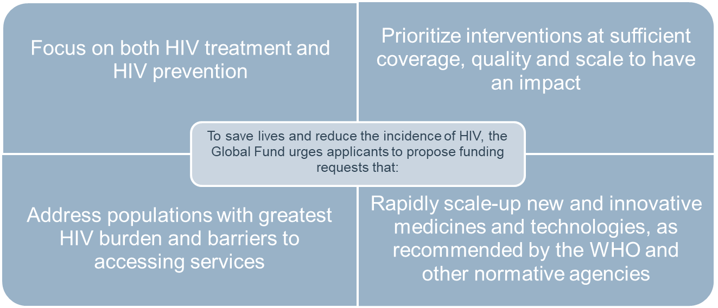

- Global Fund and partner-recommended prioritized interventions across the HIV cascade – (Note: Applicants should provide a strong rationale when not including prioritized interventions in the funding request. An example could be when and activity is already being funded through another source, either domestic or international.):
Prevention
  - HIV prevention programs addressing key populations (KPs) in all epidemic settings, and AGYW and adolescent boys and men in high prevalence settings
  - Comprehensive condom programming
  - PrEP programs for populations with substantial HIV risk
HIV testing services
  - HIV testing services strategy that uses up-to-date and regularly reviewed data
  - A strategic mix of differentiated approaches, including self-testing, that improve testing coverage, testing yield and efficiency of HIV testing services
  - Interventions that ensure people across all age, sex and risk categories are linked to the services they need depending on their test results
HIV treatment and care
  - Scaled-up DSD models that offer a mix of interventions at both facility and community levels
  - Rapid initiation for all people diagnosed with HIV and strong mechanisms to retain people across the cascade
  - Introduction at scale of optimal ARV regimens in line with WHO recommendations
  - Advanced HIV disease pathways
  - Optimized VL testing at scale as preferred treatment monitoring
  - TB preventive treatment (TPT) at scale in countries with high burden of TB/HIV
HIV strategic information
  - Routine review of data tracking people along the HIV prevention, testing and treatment cascade
  - HIV case surveillance
UNAIDS-endorsed key human rights components, scaled up and integrated into prevention and treatment programs
NSP development and data collection pre-requisite for sound funding request.
- Modular framework
  - The Handbook provides guidance for countries on how to summarize activities in the Global Fund Funding Requests and grants – explains what goes where
  - Modular framework is not a template to fill but serves as reference data for drop-down lists in Performance Frameworks, budgets and progress updates
  - Modular framework includes a set of core indicators for HIV, TB, Malaria and RSSH. Purpose of the list of indicators is to assist applicants/PRs in selecting a small sub-set of indicators (10-15) for grant performance monitoring based on the modules supported by the grant
  - Key changes in the modular framework include
    - Focus on cross-cutting systems approach including integration of services where applicable
    - Several new interventions added and scope of activities expanded
    - New population groups (i.e. AGYW in high prevalence settings, Men and boys in high prevalence settings, Non-specified population groups, partners of PLHIV, Adults and children (for Treatment module)
    - New intervention for mobile populations added: refugees, migrants and internally displaced people (TB/HIV module only)
    - Additional fields added in performance framework and detailed budget template
    - Population groups in Prevention and Differentiated HIV Testing Services modules
    - Age dimension (adults and children) in Treatment, care and support module only

WCA epidemic data, priorities –
- 90-90-90 cascade (2019) : Access to testing and treatment is low in WCA (64-79-75* ) compared to ESA (85-79-87) and globally (79-78-86). *= 64% of PLHIV know their status, 79% of those who know their HIV status are on ARV, 75% of those on ARV have suppressed viral load
- HIV testing and treatment cascade (2019): is low in WCA (64-51-39**) compared to ESA (85-67-58) and globally (79-62-53).**= 64% of PLHIV know their status; 51% of PLHIV are on ARV, 39% of PLHIV have suppressed viral load
- Uneven progress in reducing both AIDS related deaths and new infections in WCA
- For the first time, more than half (64%) of all new HIV infections globally are occurring among key populations and their partners
- Young men and women are still heavily infected by HIV in WCA - In WCA young women and young men account (15-24 yrs) for respectively 44% and 30% of HIV new infection among 15+ women and 15+ men
- WCA faces extremely low coverage of ART among children (28%) and Early infant diagnostics (27%)
- Majority (58%) of new infections among children occurs from women who are not on ART during pregnancy (37%) and breastfeeding (32%)
- In WCA, a worrying reduction in the no. of pregnant women living with HIV receiving services to prevent mother-to-child transmission from 61% in 2014 to 59% in 2018
- Compared to the previous year, the total amount of resources for HIV response in ESA in 2018 decreased by 7% and in WCA by 10% (adjusting for inflation). Great dependency on Global Fund support to the HIV response particularly in non-PEPFAR countries
- Share of HIV funding for prevention in total spending is low and will not enable WCA to reduce new HIV infections to reach the 2020 targets
- Priorities: Human rights, women and girls in particular ; Children; Key populations and their sexual partners; Financing (political mobilization to keep HIV on the agenda, domestic funding to reinforce ownership, ending user fees for health services); The health and rights of migrants and people on the move, and people in fragile settings (conflict, emergency, etc); Combination prevention; demystified testing, differentiated and community-led service delivery; Amplifying the voice of movements for social justice
- Key data source: http://aidsinfo.unaids.org/ Including Key Population Atlas; Financial dashboard; Laws and policies analytics. Spectrum files can be requested from the website. WCA Data hub, an online central repository of documents and data on HIV, to be launched shortly.

Global Fund investment approach –
- Rationale: a focus on innovations and quality for HIV and HIV/TB programming to become more efficient: directing resources to most effective program areas and ensuring quality service delivery
- a comprehensive approach that addresses critical enablers such as human rights, gender, health and community systems which must be strengthened to achieve significant progress in the region
- Focus:
- 1. First 90 and referral to treatment
  - Implementation of differentiated HIV testing strategies (including EID & strengthening of lab systems)
  - Portfolio Optimization –additional funds committed to support increase in ART coverage in 8 countries in WCA. In -country support (partners) needed to improve portfolios and Prioritized Above Allocation Requests (PAAR), focus on RSSH and prevention.
- 2. Critical enablers
- South-south learning: Defining Differentiated Service Delivery (DSD) and quality in WCA context (efficiencies through program quality/DSD: Decentralization, task shifting, multi-months ARV scripting; cascade analysis; ART cohort audits -> program adaptation)
- Resilient Sustainable System for Health (RSSH): build adequate and competent health workforce, improve service delivery
- Community System Strengthening (CSS): strengthen role of Civil Society (CS), promote advocacy, enable community monitoring;
- Equity and removing human rights barriers;
- Data quality: HMIS, cascade analysis and cohort audits.
- Needed under new allocation – focus on critical gaps in prevention in WCA. Largest gaps in Key populations (KP) prevention: Cameroon, DRC, Ghana, Nigeria. Largest condom gaps: Ghana, CIV, DRC, Cameroon, Liberia, Nigeria, Guinea-Bissau.
- Use latest data (including at sub-national level) to inform strategies and funding request.

National strategic planning and prioritisation –
- National Strategic Plans (NSPs), Global Fund applications, PEPFAR Country Operational Plans (COPs) and Investment Case Studies - We are trying to harmonize planning and expenditure tracking across organizations. We use similar typologies to track expenditures incurred by the government, the Global Fund and PEPFAR. We also want to be able to map expenditures so that they are consistent with National AIDS Spending Assessments (NASAs).
- Developing an investment case is an important step in optimizing resources and prioritizing HIV in the context of competing demands. Ultimately, investment cases need to be operationalized and implemented to have a meaningful impact on national aspirations to reduce health burdens, increase value for money and generate overall cost savings. Until now there has been only limited systematic effort to match investments to needs.
- In contrast to many national HIV plans which reflect a country’s aspirations for the response, HIV investment cases use current resource allocation as a starting point to identify how best to use existing funding and to identify incremental programming and funding decisions needed to maximize impact.
  - Investment Case : What will provide the highest impact (10 / 15 years)
  - National Strategic Plan : Five year plan to develop strategies
  - Operational plan : What will be implemented in one or two years

Day 2 – presentations and reference materials are available here Day 2
Human rights and gender (HRG)–
- TRP Observations from the 2017-2019 Funding Cycle specific to HRG (WCA):
  - More investments in community systems are needed for reaching key and vulnerable populations, and ensuring better reach of key prevention and treatment programs
  - Investments to reduce new infections amongst young women is needed, and should be aligned with the integration of HIV, RSHR and GBV services; look for best practices of programs to increase Antenatal care (ANC) services
  - Human rights interventions were not funded at-scale and integrated into the design and implementation of programs (i.e. prevention, adherence support, etc.) and impact suffered as a result
  - When countries used data from qualitative gender assessments (i.e. Gender Assessment Tool) there was better prioritization and design of interventions to address gender-related barriers, particularly for women and girls
  - Gender related barriers are as relevant for men and boys as for women and girls (i.e. designing testing approaches to reach men)
  - There is a need to engage with partners to better integrate Gender Based Violence interventions, including linkages to services
- For the 2020-2022 funding cycle, all funding applications should include:
  - HIV Prevention programming for key and vulnerable populations, including human rights interventions
  - Better data use for prioritization of sub-population and geographic focus. This includes qualitative data to understand and respond to gender and human rights related risks and barriers to services.
  - The development and expansion of civil society-led platforms for large scale program delivery for key population-targeted HIV testing, treatment, adherence support and community mobilization activities.
  - Integration of family planning and sexual and reproductive health (SRH) services into HIV care and vice versa for all women in high prevalence areas including STI prevention and treatment, family planning, cervical cancer screening
  - Increasing focus on balancing efficiency and equity, as laid out in the Value for Money Technical Brief
- 20-country Breaking Down Barriers initiative (7 countries in WCA: Benin, Cameroon, DRC, CIV, Ghana , Senegal and Sierra Leone) - providing intensive support for the inclusion, scale-up, and implementation of programs that remove human rights-related barriers to health services. Technical support is also being provided for assessments, multi-stakeholder engagement, grant implementation, and the development of plans for a comprehensive national response.
- Global Partnership for Action to eliminate all forms of HIV-related Discrimination:
  - Political and technical platform led by civil society to support bilateral and multilateral investments on gender and human rights interventions to eliminate barriers to accessing HIV testing, prevention and treatment services.
  - Co-convened by UN Women, UNDP, the UNAIDS Secretariat, the Global Network of People Living with HIV (GNP+). Focus in six settings: Healthcare, Education, Workplace, Justice, Household, Emergencies and Humanitarian.
  - The new/updated UNAIDS Guidelines, structured around the six settings, for countries to eliminate stigma and discrimination will be available in the coming weeks/ These will be critical for informing funding request development.
  - Wave 1 countries in WCA: CAR, DRC, CIV, Ghana, Senegal and Sierra Leone
- Key Questions to ask yourself during Funding Request development
  - Is the epidemiological context explained with sex-disaggregated data, particularly for core indicators (prevention/treatment cascade; new infections, diagnoses, etc.)?
    - Use key epi-data disaggregated by sex (and age if possible). Where available, make access to services and outcome data also sex-disaggregated.
    - If there is no sex-disaggregated epi-data, include data collection, analysis and capacity strengthening under the RSSH module: Health information systems and M&E.
  - If sex disaggregated data does exist, does the epi-data reveal inequities by age/gender in new infections (incidence), prevalence, diagnosis, treatment access, knowledge of disease transmission, morbidity, mortality, treatment completion, and other key indicators?
    - If yes, ensure interventions addressing affected populations/sub-population (by gender) and disproportionate burden are included in the proposed programs, with adequate budgets.
    - Describe gender and other barriers to accessing services, including for boys/men, in the funding application and how these are resolved in the proposed interventions
  - Are reliable size estimates available for key populations that is driving proposed programmatic coverage targets to reach scale between Global Fund and other available investments?
    - If yes, review service package for key populations for inclusion of critical package components, and ensure adequate coverage levels for key populations that considers absorption and implementation capacity
    - If no, include either IBBS or other survey instruments in the funding request in the HMIS module
  - Are the indicators included in the PF broken down by appropriate age and sex disaggregations?
  - Is the country part of the Breaking Down Barriers initiative?
    - If yes, review the baseline assessment and ensure that recommendations are addressed in the funding application
    - If yes, consider whether additional technical assistance is required to articulate the request and request TA through the Human Rights SI.
  - Does the Funding Request identify critical areas to improve capacity of implementors to address human rights and gender-related barriers?
    - If no, see if technical assistance is supported elsewhere and if not, include funds for qualitative assessments in the funding applications (PLHIV Stigma Index survey, stigma and discrimination indicators and National Composite Policy Index (NCPI) in the most recent Global AIDS Monitoring report, baseline assessments, legal environment assessments, UNAIDS Gender Assessment tool, etc.)
    - If yes, review human rights interventions to ensure comprehensive approach
    - If yes, review the interventions proposed to ensure that gender barriers are addressed particularly for key and vulnerable populations and their partners
  - Do the Performance Frameworks include any of the human rights indicators, part of the HIV and TB core indicators list?
    - If no, refer to the guidance and develop for inclusion
    - If yes, review to ensure that they are aligned with the guidance
  - Could GF Community Rights and Gender (CRG) TA help inform the articulation of human rights and gender-related barriers and the programs to remove them? Are communities interested in such support?
    - If yes, work with the CCM to develop an application for technical assistance
- GF CRG Short-term Technical Assistance. Technical assistance can be requested in the following areas: situational analysis and planning; Participation in country dialogue; Program design; Oversight and monitoring of grant implementation; Engagement in sustainability and transition strategy development
- UNAIDS Technical Support Mechanism (TSM) - examples of recent WCA HRG TA:
  - Ghana: Development of the Strategic Plan for a Comprehensive Response to Human Rights-related Barriers to HIV and TB Services in Ghana 2020-2024;
  - WCA regional: Review of the Dakar Declaration on Key populations; Training of Youth Network Leaders in HIV Advocacy Strategy;
  - Sierra Leone: Stigma Index Study;
  - CIV: Development of a five-year strategic plan on human rights;
  - Benin: Gender Assessment;
  - DRC: Consultancy to support capacity building for Justice Sector actors and legal clinics in HIV and human rights

Community mobilization and health –
- 83% of WCA countries have taken measures to implement a Community disease response system with varying degrees of progress. Main challenges:
  - Payment systems, wage and monetary incentive financing;
  - Recruitment, training and retention of community health workers;
  - A guaranteed offer of relevant services and sufficient availability of health workers to provide them;
  - Mechanisms for supervising and reporting on the work of community health workers.
- Fifteen NGOs were principal recipients in the region under the NFM 1 cycle. They have helped countries to scale up community activities, work with key populations and support the planning, procurement and distribution of health commodities.
- UNAIDS has done a regional mapping of Community based organisations (CBOs)’ contribution to 90-90-90 cascade in 11 countries , followed by national CSOs dialogues to strengthen community interventions.
Key findings:
  - Low formal recognition of CBOs: While providing important community services, CBOs face uneven "official" recognition of their role (which rarely translates into supportive policies, operational contracts, and accountability mechanisms).
  - Weak CBO capacity: The acceleration of CBO contribution to national responses is generally hampered by insufficient professionalization of CBOs, reduced funding and a lack of public sector confidence in the quality of expanded community services.
  - Low coverage of community provision: Community-based services highly concentrated in the country's capital and some regional capitals, with significantly lower coverage at the local level. CBOs are often the main service providers to key populations in the region.
  - Mechanisms for coordination, quality assurance and partnership between CBOs and the public sector are rare and poorly implemented.
- Priority operational modalities for CBOs:
  - Scaling up index and self-test screening modalities
  - Scaling up demedicalised treatment with the multi-monthly Community prescription
  - Expansion of community retention support programs (legal literacy, PLWHA support groups, Community ART Groups)
  - Condom programming
  - Pre-exposure prophylaxis
  - Implementation of the Stigma Index, gender assessment tool and development of multi-stakeholder advocacy plans
  - Expansion of community observatories to monitor service quality, availability of treatment and stockouts, and customer satisfaction
- WCA CSO Health and HIV Institute - Focus thematic areas: Advocacy and Leadership; Access to quality services; Removal of political & human rights barriers; Monitoring, accountability & early warning ; Support and funding for a greater participation ; For GF application: will mobilise community experts share , provide guidance to CSOs and document and share good practices
- RAME – GF regional platform for francophone West Africa – set up a working group on TA for CSOs; trained community experts; working on a dashboard to track implication of CSOs in GF processes
- The Regional Community Treatment Observatory in West Africa (RCTO-WA) is a consortium project led by the International Treatment Preparedness Coalition (ITPC)
  - The project works to increase access to optimal HIV treatment in 11 West African countries (Benin, Côte d’Ivoire, Gambia, Ghana, Guinea, Guinea-Bissau, Liberia, Mali, Senegal, Sierra Leone, Togo) through the systematic monitoring of services by national networks of people living with HIV.
  - the RCTO-WA collects and analyzes data on availability, accessibility, acceptability, affordability and appropriateness of HIV care and services.
  - The project has a particular focus on access to, and quality of, HIV services for five priority populations: pregnant women, young people, men who have sex with other men, people who inject drugs and sex workers.
  - Supported by the Global Fund until end 2020. Plea for the model to be taken into account in funding request development.
- Thematic review underway to better understand how Global Fund’s current investments in community health care contribute to scaling-up effective interventions for HIV, TB and malaria, in selected countries. Specifically, the review is aimed at identifying and documenting successes and challenges in the planning, implementation and monitoring of community health care.” Undertaken by Enda Santé for the Global fund in 8 countries (DRC, Ethiopia, Ghana, Liberia, Mali, Mozambique, Niger, Zambia)
- Spotlight on family testing – Main enablers of Family HIV Testing piloting from countries are:
  - Involvement of community-based organization (including PLWA for peer support) for psychosocial support to families linkage and retention in continuum care.
  - Disclosure support & peer support mechanisms
  - Orientation sessions/training of key stakeholders: prescribers, HIV counsellors, pharmacists and pharmacy staff, midwives, CHW and members of the community-based organization
  - Constant support/monitoring visits to assess the level of implementation

Domestic Resources Mobilization, Co-financing & Sustainability –
- Key pillars of Global Fund work on sustainability, transition and co-financing:
  - Support countries to develop robust national health strategies, health financing strategies and national disease strategic plans
  - Encourage additional domestic investments; require minimum 15% co-financing for each grant
  - Accelerate efforts to prepare for transition, particularly for upper-middle-income and lower-burden, middle-income countries
  - Strengthen focus on key populations and structural barriers to health
  - Work with partners to advocate for programmatic and financial changes
  - Strengthen alignment between Global Fund grants and country systems
  - Support countries to identify efficiencies and optimize disease responses
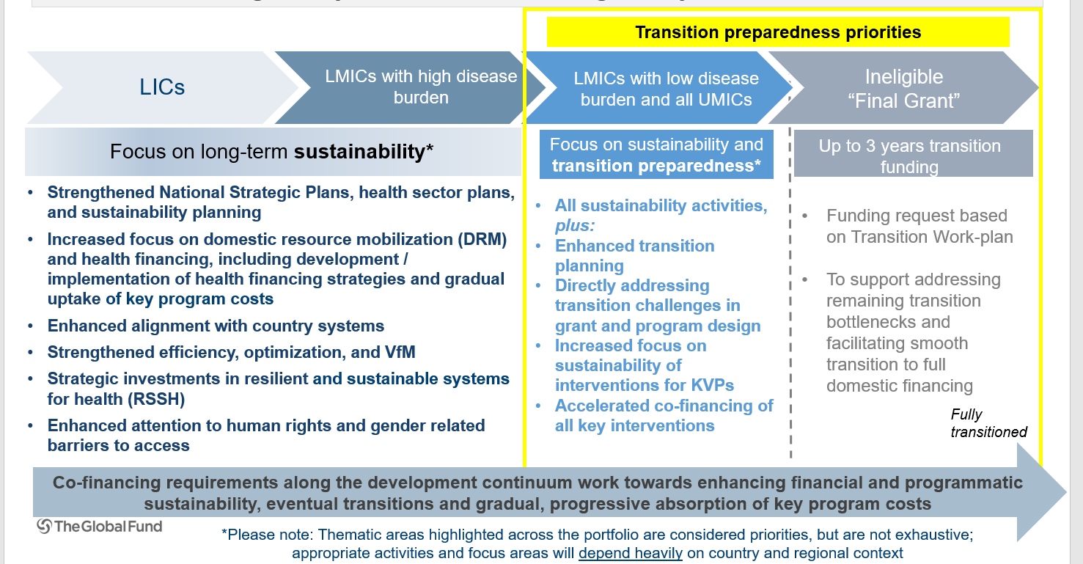
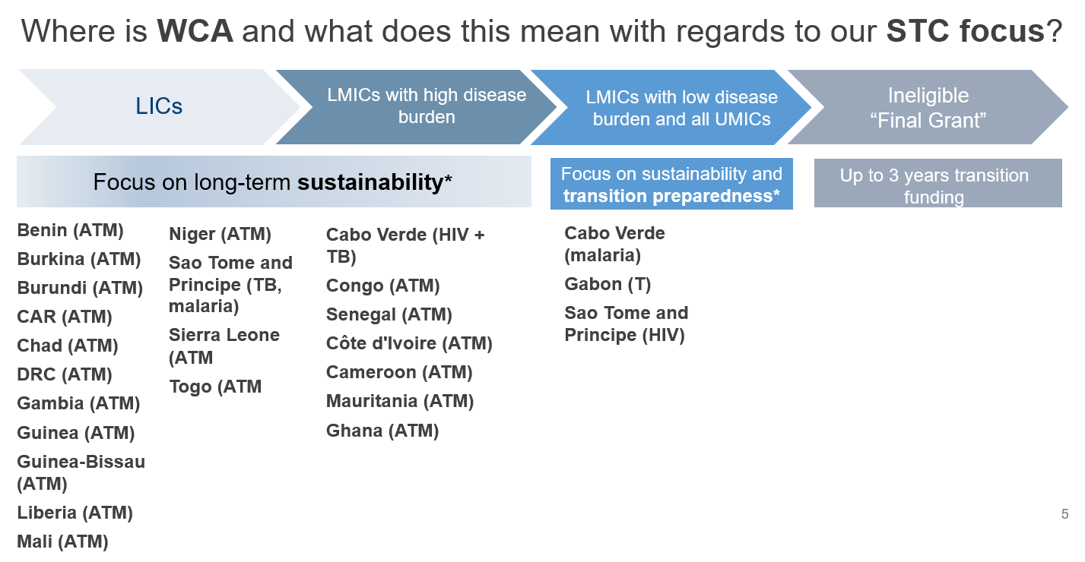
- Co-financing incentive with More flexibility to focus on health systems in Low Income Countries (LICs) and Low Middle Income Countries (LMICs) and More targeted focus on disease programs, key and vulnerable populations, and transition and sustainability priorities as countries. Co-financing = domestic public resources and domestic private contributions which finance the costs of the NSPs supported by the Global Fund. Can come from: gov’t revenues; loans from external sources/private creditors; debt relief; social health insurance; verifiable contributions from domestic corporations/ philanthropies that finance NSPs
- Illustrative positive examples of co-financing in the WCA region:
  - Use of Wambo procurement mechanism with domestic financing to ensure availability of commodities at competitive prices and in a timely manner;
  - A low income country financing 45% of funding need from domestic resources, which support procurement (including ARVs) PMTCT, prevention programs, etc;
  - Some countries have made efforts to increase prioritization of health (one example of 12% of gov. expenditure allocation to health); and others have recently announced increases in health budget
- Enhanced instructions in the Funding Requests on what the Global Fund wants in the financing and Sustainability & Transition sections. What is needed in the Funding requests :
  - Clear analysis & enhanced emphasis on sustainability: Understanding of current challenges & current plans/proposals to address them. Based on country context.
  - Considerations on efficiency: Considerations on both allocative & technical efficiency, linked to existing country studies & strategies.
  - Enhanced national planning related to sustainability (including health financing strategies)
  - Enhanced focus on integration (including community activities)
  - Domestic Financing: Evidence of domestic efforts to mobilize funding for the three diseases and health systems at national level – partners, private sector, national budget; enhanced focus on co-financing commitments for certain interventions (i.e., Human resources for health) and monitoring
  - Expenditure Tracking: Clarity on expenditure tracking & reporting at national level
  - Human resources for health (HRH): Clear vision and plans for developing robust HRH, coordinated and harmonized approaches that are government led, and co-financing commitments for HRH
  - Enhanced clarity on strategic investments in RSSH: Strategic investments in systems to enhance sustainability, including data, performance framework management, supply chain management
- Tips and Considerations for Co-financing and Sustainability & Transition sections
  - The Funding Request section needs to match the funding landscape plus the commitment letter; in the past, funding landscape not always aligned to commitment letter
  - Commitments should be as clear / specific as possible, including in terms of overall investments in health and specific investments in disease programs / program costs is looking for
  - Include solid analysis of sustainability challenges relevant to country context. These can be financial or non-financial (i.e., programmatic, governance related, human rights, health systems related, etc);
  - Consider long-term reforms (including health reforms) & solutions (backed up with country strategies & partnerships), e.g.: How to change behaviors in health system; RSSH investments that contribute towards sustainability and support strengthened disease response; etc.

Key populations Panel –
- Sierra Leone presented its successful key populations programme implemented by NGOs (3 organizations targeting Sex workers and 1 each for MSMs and PWIDs) in close collaboration with NACP where a consortium of KP organizations for the Advancement of the Rights of Key Affected Population (CARKAP) is in place. Peer Educators identified among the key pops trained to reach out to their peers ; Peer educators follow up on 20 new peers for HIV sensitization, testing, STI screening. Peer educators are assigned to peer navigators; Peer navigators assist and supervise peer educators, Peer Navigators link HIV positive clients to care and track them for retention. A complain desk officer at the IP level work with Legal Aid Board and police to prevent violation of rights
- Cameroon presented its key populations programmes led by two NGOs working in collaboration with key population associations, doing prevention, HIV testing and support for people in ARV care. The care of key populations is currently based on two complementary strategies : Hospital and community care. HIV positive persons are linked (via peer navigators or an orientation ticket) to specific hospitals where staff (Doctors and psychosocial counsellors) have been specifically trained on issues of key pops and stigmatization. Key populations associations are also involved in community ARV delivery, for stable HIV-positive patients who have an undetectable viral load. These patients remain linked to health facilities where they have been initiated into treatment for clinical follow-up and biological check-ups
- The network of key populations in Senegal shared its experience of demedicalized testing, and community peer mediation to identify people at risk, and ensure linkage to treatment services, the search for the lost to follow-up, and the facilitation of support groups. The network has also, through a regional grant from the GF, via Enda Santé, been able to organize dialogues in police stations to reduce violence against sex workers. The results on Senegal's 90-90-90 are due to this community involvement, and the flexibility and availability of people from these communities. She called for strategies to be developed to integrate people with mental and physical disabilities into HIV programmes; for the economic and financial precariousness of key populations to be taken into account; for the needs of specific groups, including older women and young people with intellectual disabilities to be considered; for more resources to be provided to community associations that have lost funding from prevention programmes. She also shared the establishment of the Women's Federation for Development, which unites associations, incl of sex workers, working on women's empowerment and willing to contribute to the development of society.
- Côte d’Ivoire presented the preliminary results from its HIV self -testing pilot and its plan for Prep pilot. Main challenges on HIV self-testing pilot are as follows
  - Regular and continuous supplies to district pharmacies
  - Reporting and monitoring of data;
  - Involvement of health care providers, communities and PLVIH;
  - Self-test cascade (from screening to ARV treatment)
  - Deadline for the return of results (2 to 3 weeks for self-tests);
  - Social and economic impacts of self-tests and PreP to be evaluated (Multi-country study in Côte d'Ivoire, Burkina Faso, Togo, Mali on acceptability and feasibility of PreP for MSM- Oct 2017- Sept 2020)

Resilient and Sustainable Systems for Health (RSSH) –
- Current Global Fund Strategy prioritizes seven RSSH areas
  - Strengthen community responses and systems
    - Community-based monitoring
    - Community-led Advocacy
    - Community mobilization, linkages, collaboration & coordination
    - Capacity building, planning & leadership development
  - Support reproductive, women’s, children’s, and adolescent health (RMNCAH) and platforms for integrated service delivery –
    - Four areas prioritized for investment: Ante-natal and postnatal care; Child health (integrated community case management); Integrated sexual and reproductive health (SRH)-HIV services; Adolescent health
  - Strengthen global and in-country procurement and supply chain systems
    - 40% of Global Fund investments are for procurement and supply-chain management of health products. It’s a key risk area.
    - Support pooled procurement mechanisms where needed while encouraging countries to strengthen national procurement systems.
    - Strengthen national supply chains. Work with partners to evaluate where multiple supply chains can be integrated and mobilize in-country support.
    - CCMs can establish sub committees to oversee Procurement PSM related issues
  - Leverage critical investments in human resources for health (HRH)
    - About 10 % of the portfolio is spent on HRH. Investments need to be more strategic
    - Investments need to be aligned to national HRH policies, which should be informed by HRH labour market analyses
  - Strengthen data systems for health and countries’ capacities for analysis and use
  - Strengthen and align to robust national health strategies and national disease-specific strategic plans
  - Strengthen financial management and oversight
- Overall, applicants should consider the new RISE principles of being results focused, using innovative approaches, applying systems thinking with a focus on innovative financing mechanisms, and thinking about equity and reaching the poor.
- The Technical Review Panel (TRP)’s comprehensive review of funding requests
  - found that most investments focused on data systems (boosting the adoption of the district health information system 2 (DHIS2) and other interoperable systems for disease and public health program monitoring); human resources for health (including the development of multi-disciplinary cadres at community levels); and supply management systems (such as improving access to diagnosis and medicines at ‘last mile’ facilities.
  - investments were largely focused on support activities more in keeping with early stages of health systems development (for example salary support and short-term training);
  - monitoring indicators for RSSH were weak;
  - integration was lacking, both across the three diseases and within RSSH systems (for example commodity procurement);
  - gaps remain in comprehensive engagement beyond the Ministry of Health (for example with the Ministry of Finance); and
  - very little attention was paid to other areas of health systems strengthening like governance, financial management and community systems.

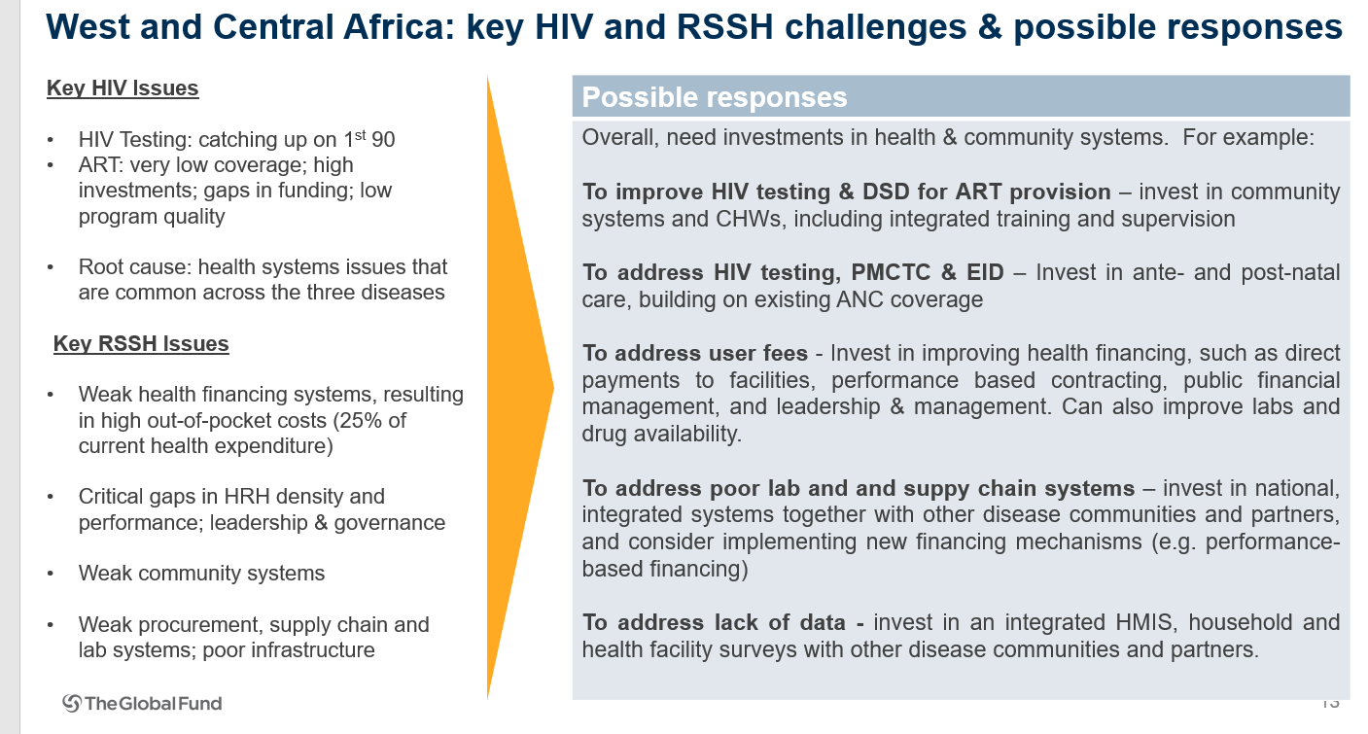
- Global Fund Strategy emphasizes importance of integrated service delivery for women, newborns, children and adolescents. Countries must critically evaluate the packages of services and models of delivery that are most appropriate and feasible for integration. Various levels of integration include:
  - Health systems functions: National procurement and supply chains; National health management information systems (surveillance & surveys); National laboratory systems (e.g. integrated sample transport systems; polyvalent diagnostics); National health workforce (e.g. multi-use community health workers)
  - Governance and health financing: Coordinated strategic and operational planning, and health financing across various health programs; (e.g. coordinated disease NSPs and health sector strategies, budgets and financial flows);
  - Service delivery level: Organize services at the facility level around a package of essential health services, plus functional referral system. (e.g. ANC/PNC, iCCM, SRH-HIV, adolescent health service delivery platforms)
- Tips on RSSH & the funding request process
  - Conduct inclusive country dialogue: countries are strongly encouraged to discuss RSSH upfront, and develop a comprehensive approach, ensuring that it covers the needs of all eligible diseases. Relevant RSSH actors should be involved in these discussions with the CCM
  - Agree on amount for RSSH - Program split: Countries are informed of their overall allocation, and an indicative amount for each eligible disease component (i.e. program split) in the Allocation Letter. Applicants use a documented and inclusive process to confirm or revise the program split for the three diseases. Funding for RSSH should be earmarked from the overall allocation but does not need to be noted in the program split unless a standalone RSSH funding request will be submitted. Analytics from RSSH Dashboard can help guide applicants in this discussion.
  - Agree on application modalities for RSSH: Countries are requested to apply for RSSH in first application: Can be together with a disease application or can be a separate RSSH application (there is no RSSH application template; use normal forms).Countries are encouraged, where possible, to submit integrated funding requests (consisting of HIV, TB, malaria and RSSH components), or simultaneous submissions of individual funding requests to ensure coherence.
  - Apply systems thinking and identify common bottlenecks. Disease teams should communicate about RSSH issues during the funding request preparation. Conduct needs assessment/gap analysis, including funding landscape analysis
  - Requests should be based on sub-sector plans (e.g. RMNCAH, HRH, Procurement and Supply Management (PSM), Health Management Information Systems (HMIS), Integrated Laboratory Services, Public Financial Management (PFM) Remember to add PAAR

Day 3 - presentations and reference materials are available here Day 3
Prevention –
- Reaching high coverage of effective prevention, testing & treatment among key populations is the first priority for reducing new HIV infections across the region. This needs to be complemented by scaled condom programming and - based on country epidemiology – in some locations highly focused prevention programmes for young women & male partners and PrEP
- Prevention programmes for key populations
  - HIV prevention with key populations is high-priority in all countries (based on epidemiology, value for money and rights considerations); 64% of new HIV infections in WCA are among key populations and their sexual partners
  - Established approaches can be implemented at scale and the upcoming round of Global Fund applications is a major opportunity to make progress;
  - Challenges of key populations programming in WCA
    - Lack of or inadequate definitions of coverage for most interventions
    - Some key populations not recognized in national design documents (eg Transgender); some recognized but no package designed (PWID or prisoners). Key gaps: Inadequate inclusion of needle-syringe programs and opioid substitution treatment for PWID and prisoners; New elements: PrEP and overdose prevention not included in majority of countries; Community empowerment rarely mentioned in design documents
    - Condom programming in place but problems with appropriate quality, consistency of supply and availability of appropriate lubricant
    - Ambitious testing targets leave little time and resources for a broad prevention and health engagement with KP
    - Social media outreach to KP is increasingly becoming an essential element of services, but requires standard setting and guidance
    - There is need for scaled community platforms for KPs for prevention, treatment & rights.
    - In parallel, legal, policy and structural barriers should be addressed.
- Condom programming
  - 45 million infections have been averted by the historical scale up in condom use from 1990-2015
  - Funding for male and female condoms is a smart investment : An additional investment of $27.5 billion in male condoms in 81 high-burden countries by 2030 would meet all unmet demands for family planning as part of a package of contraceptives. It would also meet: 90% of the condom needs for HIV and STI prevention among high-risk groups. And it could prevent: 700 million STIs, 17 million HIV infections, 420 million unintended pregnancies
  - There is little to no coordination on condom procurement at the global level, although a recent MoU outlining the roles of GF and UNFPA procurement is likely to help
  - All countries fall short of global condom use targets, some by substantial amounts. Double-digit gaps in use between urban and rural populations as well as between wealthier and poorer populations persist in most countries
  - Condom use in younger segments shows signs of stagnation or decline in at least a few key countries
- Prevention programmes for adolescent girls & young women (AGYW)
Recommendations:
  - Sharpen geo-spatial analysis of HIV incidence settings for AGYW & male partners
  - Improve targeting to ensure we reach the most vulnerable AGYW and their male partners
  - Targeted at specific subgroup and geographic areas, based on risk analysis
  - Always combine behavioural, biomedical and structural interventions
  - Definition of national (rather than project) packages : Basic national SRH/HIV program packages, Comprehensive Sexuality Education (CSE) (nation-wide); Intensified actions in high-HIV incidence settings
  - Measurement of programme coverage - Tracking proportion of adolescent and young women reached with specific packages, Ideally with unique identifier, e.g. same girl or young women is exposed to multiple interventions
  - Challenges:
    - Limited contraceptive access without parental consent
    - Lack of easily accessible sources for condoms
    - Continued gender disparity in access to secondary education (including school retention when pregnant)
    - Comprehensive sexuality education not implemented
    - Limited focus on young key populations
- PrEP and treatment as prevention
  - HIV incidence remains high in specific geographical areas and populations - there is a need for additional choices for HIV prevention.
  - PrEP is:Very effective when used; Can be very acceptable with good adhesion; Well tolerated and safe; Feasible - with the growing experience of implementation;
  - PrEP programmes can catalyse the expansion of HIV testing and improve links to ART, and other HIV-related services.
  - Large-scale implementation is necessary to refine the offer and increase impact.

HIV Testing Services (HTS) –
- New WHO guidelines
  - Guidelines released in 2015; Supplement in December 2016; Strategic framework for implementing HIVST – October 2018; New guidelines to be release on 4th December – 2019
  - What is new : Three test algorithm to be implemented and the use of dual syphilis HIV testing for pregnant woman; Re-testing before treatment initiation: Targeted testing: index testing, partner notification, HIV testing by trained lay providers using rapid diagnostic tests (RDTs); PITC (TB, STI, malnourish, pediatric services), Multialgorithm Early Infant Diagnosis (EID)
  - HIV self-testing (HIVST) should be offered as an HTS approach for those who are hard to reach. Provision of appropriate HIVST service delivery and support options is desirable. Communities need to be engaged in developing and adapting HIVST models. HIVST does not provide a definitive HIV-positive diagnosis. Individuals with a reactive test result must receive further testing from a trained tester using a verified national testing algorithm.
  - The WCA region is lagging behind in terms of specific HIVST policies development, and implementation. Operational guidance is needed to support implementation
  - New Social network-based approaches can be offered as an approach to HIV testing for key populations as part of a comprehensive package of care and prevention
- Goals Testing tool was presented. It allows to estimate the most cost-effective testing strategies in each country to attain the goal of at least 90% of PLHIV knowing their status
- WHO HTS mobile application is available 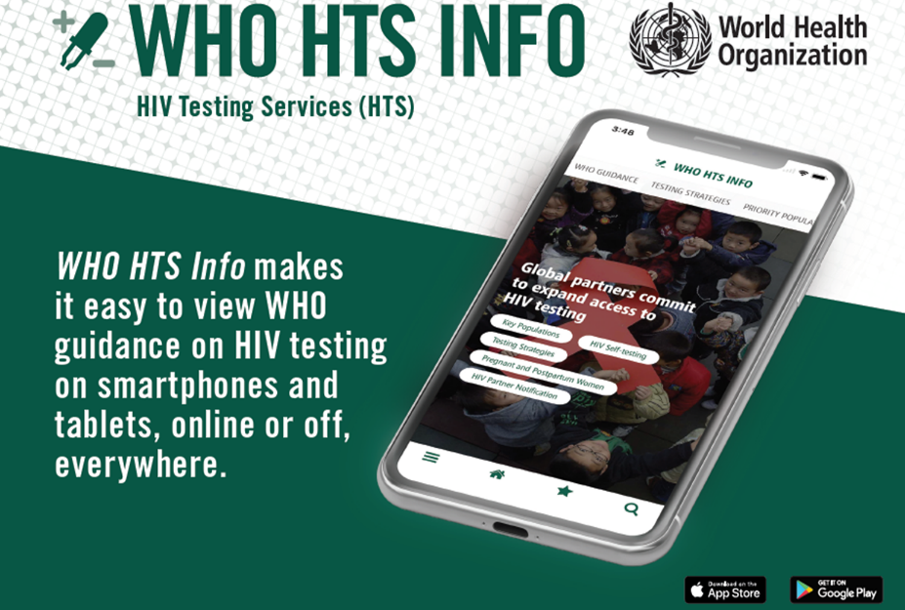. Search “HTS Info” In App Store / Google Play Or Try the link:http://www.who.int/hiv/mediacentre/news/hts-info-app/en/
- Spotlight on Self- testing – ATLAS Project (in three countries Mali, CIV and Senegal) shared their experience in Senegal -
  - Specifc HIVST supporting tools have been developed to promote correct use,
results interpretation and link to confirmatory testing and care : leaflet, video, free hotline, Dispensing agents tools (trainers manuals, fact sheets, demonstration tools)
  - Training modules developed and validated with partners and available for free: https://aidsfree.usaid.gov/resources/hts-kb/posts/hivst-west-africa-training-curricula-and-hivst-supporting-tools
    - 6 key elements to introduce HIVST in GF funding requests - Situational analysis and implementing plans shall ensure/integrate:
    - Target population definition, delivery channels and dispensing strategies design.
    - Integration within national system and strategies (Testing policy and normative docs, HIVST guideline, PSM) and mobilization of existing HIV partners network and target population.
    - HIVST demand creation strategy without replacing existing testing strategies (HIVST = screening).
    - Adapted HIVST supporting tools to ensure accurate use, results interpretation and link to confirmatory testing and care (hotline, demonstration video etc…)
    - Dispensing agents training minimum standards to ensure quality, cost effectiveness and scaling up.
    - M&E integrated system without systematic HIVST result tracking in line with WHO recommendations
- Spotlight on Index testing and partner notification : Cameroon presented its HIV index testing approach in health facilities or in the community
  - Several options are recommended to refer partners from the "index case" to screening (Direct, Made by a provider, Contractual, etc).
  - Target populations are : Biological children, Sexual partners, Needle-sharing partners, Sibling members (for index children)
  - Challenges were: Reluctance of index cases to contact sexual partners; Difficulty in announcing status to partners by index cases; Status announcement to young people and adolescents; Refusal of referred persons to participate in screening

Infant/mother, children adolescent and youth diagnosis, treatment and retention –
- In WCA only 28% of children (aged 0-14) living with HIV receive ART treatment.
- Progress in PMTC coverage has flatlined since 2014. Majority (58%) of new infections among children occurs from women who are not on ART during pregnancy (37%) and breastfeeding (32%) Coverage of Early infant diagnostics (27%) is very low.
- 79 adolescents (aged 10-19) became infected with HIV every day in the region in 2018.
- 5 countries (Nigeria, DRC, CIV, Cameroon, and Ghana) represent 75% of new infection among both children and adolescents
- Key challenges are as follows:
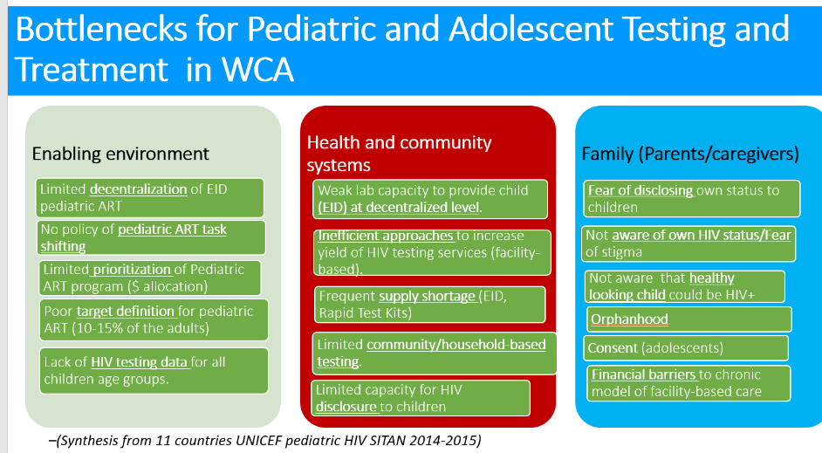
- A dozen key strategic activities identified toward the actions of the renewed 2015 Dakar Call to action towards the elimination of mother to child transmission and universal coverage of testing and treatment services for children by 2020
1. Task-shifting in support of the decentralization of HIV services.
2. Scaling up of family-centered HIV testing.
3. Use of modern HIV testing techniques (combined HIV-Syphilis test in ANC and POC technologies)
Conventional diagnostic (PCR) platforms have limitations in WCA context and Point of Care (POC) performs better compared to Conventional platform. POC scale up
  - 2016-2020: Ongoing UNITAID funded project in Cote d’Ivoire, Senegal, DRC and Cameroon
  - 2018-2021: Ongoing UNICEF funded scale-up project in 10 Countries (Nigeria, Ghana, Mali, Chad Burkina Faso, CAR, Congo, Equatorial Guinea, Gabon, and Cabo Verde).
4. Strengthening community systems, local governance and the effective participation of communities and civil society.
5. Scaling up of differentiated HIV services
6. Use of optimized treatment regimens for HIV-infected infants.
7. Adoption and effective use of modern e-health techniques involving information and communication technologies
8. Use of disaggregated HIV program data (by age, gender and location)
9. Promoting non-restrictive policies and legislation
10. Promoting universal health coverage (UHC) policy and legislation
11. Reducing dependency on external financing

Increased treatment programme quality –
- WHO latest recommendations on treatment and viral load
  - 2019 WHO ART guidelines : What has changed: DTG for all, given the fact that the NTD side effect is largely decreased considering the last Tsempano study results.
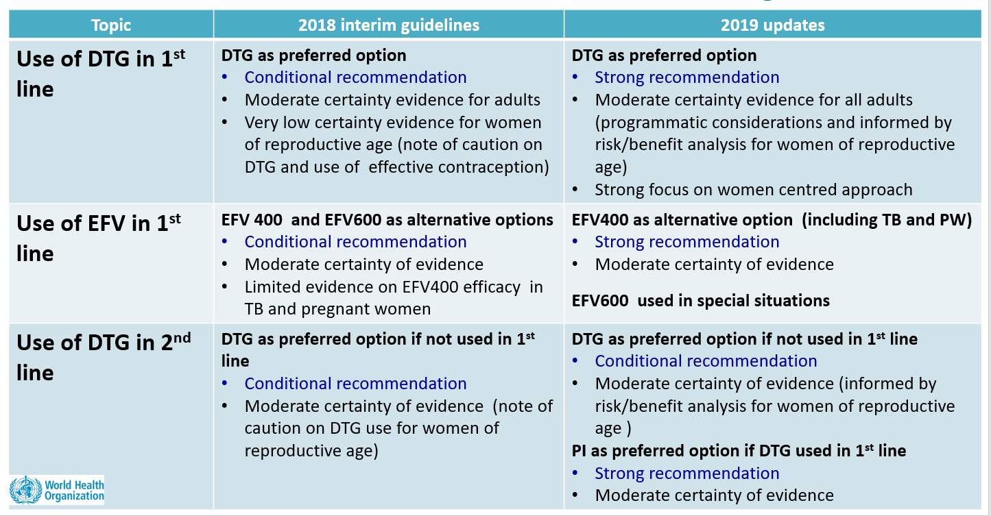
  - New WHO HIV Tx Application on mobile phones : https://hivtx.org
- DRC outlined its approach for Differentiated Service Delivery (DSD):
  - Testing: Systematic screening strategies for Key Populations, pregnant women, tuberculosis, contact cases and STI cases; Targeted screening strategies for general consultation, intensive care and inpatient screening; Index testing (health facility and community); Self-test
  - Started differentiated care first informally through the PODI drug distribution posts, followed by the introduction by some PEPFAR Implementers Partners in some health facilities. The need to create PODI emerged because of the increasing number of patients in some health facilities, particularly those supported by MSF. Following a multi-partner mission to the country, it was recommended that the country integrate differentiated care models. Following this recommendation, an action plan to operationalize differentiated care models was developed. In its implementation, a manual of differentiated care models and a collection of technical data sheets were developed. Providers were trained, starting with the provinces with the highest burden of the disease.
  - The models of differentiated care in the DRC concern HIV and tuberculosis (One-stop shop), for screening (systematic screening (PMTCT, Tuberculosis, malnourished children and Key populations) and targeted screening for other groups (index testing, hospitalized patients, etc.)), drug dispensing and clinical follow-up. With regard to drug dispensing, the rapid circuit/spacing of appointments, the therapeutic community group, the compliance club and the drug distribution station are proposed.
  - A survey in two health zones where patients already had more than a year in differentiated care had shown that parameters such as retention, viral load, body mass index remained almost the same 12 months after opting for a differentiated care model.
  - This process was made possible thanks to funding from the Global Fund, but also from PEPFAR.
- Guinea presented 5 approaches being undertaken to improve quality of treatment program and retention:
  - Simplified Reproducible Model (MSR - IT tool for patient monitoring) launched in 2017 deployed in the 29 "large cohort" sites representing 80% of all PLHIV
  - ART provision for 6 months or 3 months for certain patients
  - Development and deployment of the Tracker (DHIS2)
  - Evaluation of the high cohort 29 sites and 66 PMTCT sites with Site improvement plans- from the SARA tool
  - National Strategy for Differentiated Screening
- Ghana presented how it moved its Differentiated Service Delivery (DSD) policy into practice
  - Policy covers entire continuum of care, differentiates between general population and considerations for specific populations, and includes SOPs and algorithms.
  - Process to develop the policy:
    - Baseline assessment of selected facilities: Multi-stakeholder team; Findings emphasized need for DSD across the continuum of care (February 2017)
    - Workshop on DSD (April 2017) with donor partners, stakeholders and implementers from the regions
    - WHO consultant supported development of DSD operational guidelines and manual by Dec 2017
    - DSD Task team formed with ToR (May 2018)
  - Implementation focus:
    - Key priorities in implementation plan : High client load facilities with at least 200 clients
    - Onsite orientation: Deal with site specific challenges; Get a lot more staff involved; Sub-national teams led while National officers supervise
  - Lessons learned:
    - Wide stakeholder engagement to accept model especially implementers
    - Training strategy – onsite or ‘classroom’
    - A costed plan and dedicated funding should be secured to ensure smooth operationalization
    - Periodic assessment of impact to be undertaken beyond the baseline to justify further investment
    - Procurement planning to ensure drug supply available
    - Most indicators are process indicators so better monitored during supportive supervisory visits
    - Supportive supervisory visits - A MUST

HIV/TB interventions –
- Key approaches for TB/HIV and HIV/Sexual and reproductive health integration
  - WHO recommended collaborative TB/HIV activities
  - Strengthen the mechanisms for delivering integrated TB and HIV services: Especially for TB/HIV grants the Xpert and cartridges for testing HIV patients for TB (75%) need to come from the HIV grants.
  - The countries are called to expand the TB preventive therapy according to UN High Level Meeting commitment for ending TB in 2018.
  - Investments in X-rays will be fundamental to achieving the targets set out in WHO’s End TB Strategy: countries are starting to put this into their budgets.
- Addressing Hepatitis
  - Hepatitis is killing now more than HIV, than TB and Malaria, according to the 2019 WHO report
  - Hepatitis B&C are more prevalent in the WCA region
  - We have more than 7% of coinfection HIV/Hepatitis B and more than 6% of coinfection HIV/Hep C: this is the entry point for planning hepatitis interventions in the GF funding request
  - We can plan Hep B testing for pregnant women, Hep B birth dose vaccine, harm reduction for key populations, Hep B&C screening among PLWHA, treatment for those who are hep B and/or C infected.
  - Examples of countries having addressed Hepatitis in the GF funding request HIV: Benin ,DRC and Rwanda
- Integration of RMNCAH in Global Funds proposals
  - Opportunities for integrated services delivery in each step of life cycle: pre-pregnancy, pregnancy, delivery, postpartum, postnatal, childhood, adolescence.
  - Impact of integration of HIV interventions within RMNCAH services in some countries
- Benin and DRC presented their experience on submission of a joint TB/HIV funding request –
  - DRC wrote and implemented two joint HIV/TB concept notes so far (2015/2017 and 2018/2020).
  - The writing process began with the review of the two programmes and the development of strategic plans, including the multisectoral HIV plan; and a timeline. Consultations were held, first at the provincial level and then at the national level to determine priorities for HIV and tuberculosis. After validation of the priorities by the CCM, the need for technical assistance was determined and the source of funding identified. A national team of national HIV and TB experts was set up to lead the writing of the note A workshop was organized to upgrade experts on priorities and different modules, budgets and all forms required for the note. A second workshop (residential this time) was organized, bringing together national experts and national and international consultants to write the note. During the workshop it took a good division of labour and coordination to move forward. Since only one note would be submitted for the two diseases, a group of two international consultants, one HIV and the other Tuberculosis, was responsible for integrating the productions of the different groups into the common form and ensure harmony under the guidance of the main consultant in charge of coordinating the whole process and the president of the CCM's proposal development committee.
  - During the negotiation of the agreement, documents such as the work plan, monitoring and evaluation plan, performance framework and procurement plan were developed separately and in collaboration with the selected PRs. In the first experiment, there was one PR per disease, but for the current grant, we have the same PR for both diseases.
  - The arbitration was facilitated by the prior determination of allocation for each of the diseases, the prior determination of priorities and the consensual choice of modules to be funded. Ongoing exchanges with both technical and Global Fund partners during the writing process also helped to clarify some of the difficulties. Debates were sometimes heated, and it is a tedious process for consultants to integrate inputs and updates into the note submission form.
  - Benin : NSP has integrated HIV, TB, malaria, Hepatitis, ISTs and other diseases . Challenges include: Ensuring the mobilization of resources to reduce funding gaps for all diseases covered; Making the unique Information and Logistics Management System for health inputs operational; Establishing a good integrated community alert system ensuring universal coverage of prevention and health promotion interventions; and Operationalizing the integrated approach to the governance of projects and programmes

Technical Assistance –
- UN joint programme Technical Support Mechanism (TSM)
  - TA Facility that can be accessed by Joint Programme of 11 Cosponsors . UN Country Joint Team on AIDS, together with Country partners, identify TA needs and a request is submitted to TSM via the UNAIDS Country Director
  - TSM Data base of est. 200 consultants incl over 120 with GF expertise; Databases of UN agencies with additional specific expertise
  - West and Central Africa has received the biggest share of TSM support over last two years (37%).
  - Sourced principally experts from the region, including PLHIV and community member
  - Standard ToRs have been developed for core consultants – lead, M and E, human rights and gender, community mobilisation, etc
  - Current focus on strengthening TSM technical management, coordination and quality assurance
  - TA coordination starts at country level, supported by regional/global coordination platforms :
    - Country Roadmap and one TA plan for GF funding request development
    - CCM and MOH central coordination roles to convene all partners
    - UNAIDS to help facilitate coordination efforts for HIV applications; Technical assistance can be provided to support coordination function
    - WHO TA for guidelines adoption and, HIV and TB Joint Peer Review of funding applications for the first Wave countries, during 12-14 Feb 2020 in Kenya
- Expertise France
  - Projects channel: 2017-2019: 228 missions; 20.74M€ committed. 110 beneficiaries (34% CCM - 24% PR/PN)/ 47.9% HSS - 33.3% HIV - 4.8% Malaria - 14% TB. 92.5% Africa
  - How to access TA (3 month- timeframe)
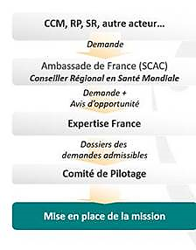
  - For a country to request TA https://www.initiative5pour100.fr/demander-assistance-technique
  - Expertise France is recruiting experts and consultants: https://www.initiative5pour100.fr/appel-candidatures
  - To date 11 WCA countries having requested TA for GF applications : Burundi, Cameroon, Cape Verde, CAR, Congo, RDC, Gambia, Guinea, Mali, Niger, Senegal.
- Nigeria and Burkina Faso shared their good practice of TA coordination at country level. Lessons learned:
  - Early TA needs assessment with clear TORs facilitated timely engagement of consultants
  - Designating One focal person for recruiting and scheduling consultants enhanced communication and shared understanding
  - Engagement of One lead consultant to manage the process improved effectiveness and efficiency of the process
  - Regular meeting of consultants ensured updates are shared on progress, changes, etc.
  - Maintaining a database of all consultants with contact information and areas of responsibility facilitated timely communication and sharing of useful information
  - Use of the progress tracker helped measure performance of the consultants on a daily basis

